Name: **ZOHAIB HASSAN SOOMRO**

RollNo#: **19SW42**

Subject: **DBS**



* **Q1. Execute the following queries and display their outputs:**
* i. Display the emp name, salary, and commission for all employees who earn commissions. Sort data in descending order of salary and commissions.

**: ANS**

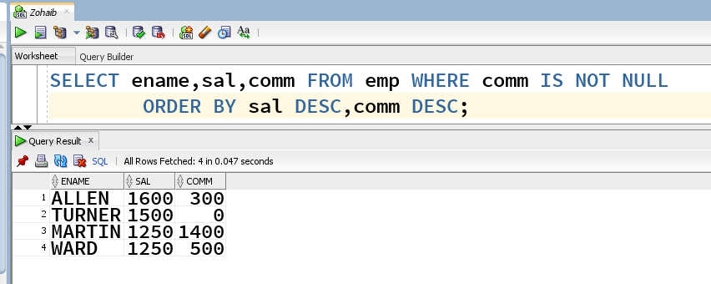

* ii) Show empno and ename having deptno 20 or 30 in descending order

**ANS:**

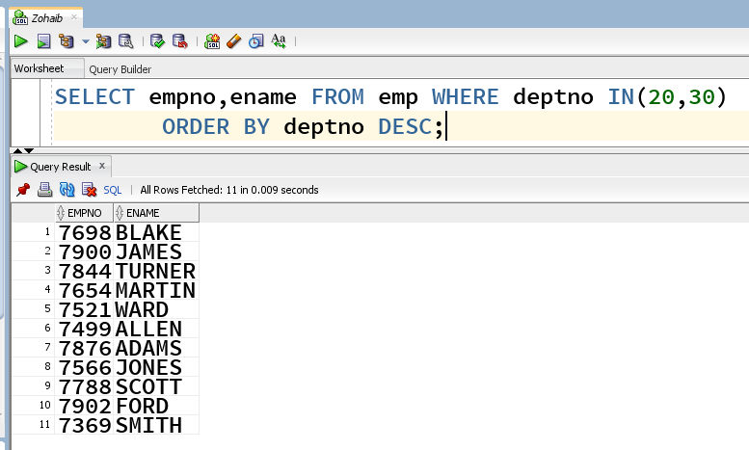

* iii. Write a query that displays the employee name (with the first letter uppercase and all other letters lowercase) and the length of the name for all employees whose name starts with the letters J, A, or M. Give each column an appropriate label. Sort the results descending order of the employee name.

**ANS:**

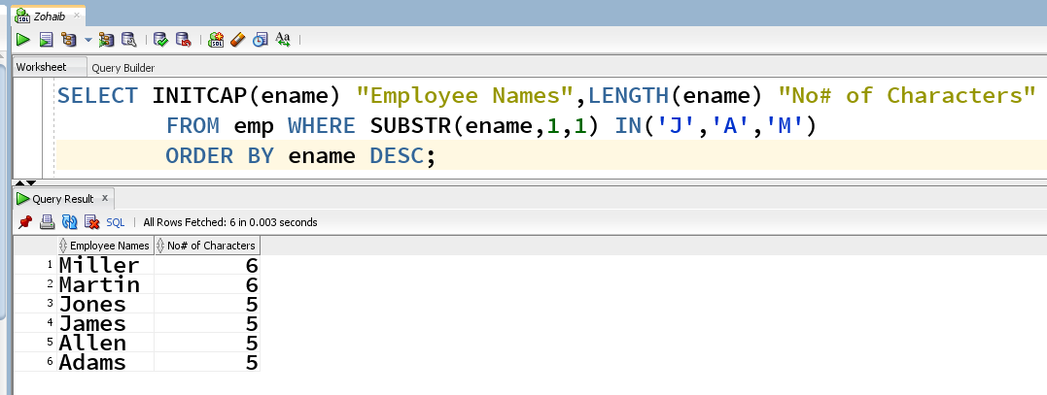

* iv.Display the emp name and calculate the number of months between today and the date on which the employee was hired. Label the column MONTHS_WORKED. Order your results in descending order by the number of months employed.

**ANS:**

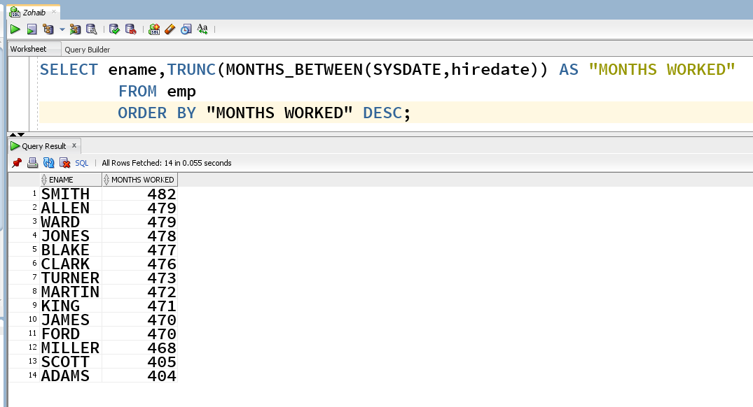

* iii. Display the emp name and salary for all employees. Format the salary to be 15 characters long, left-padded with the “$” symbol. Label the column SALARY.

**ANS:**

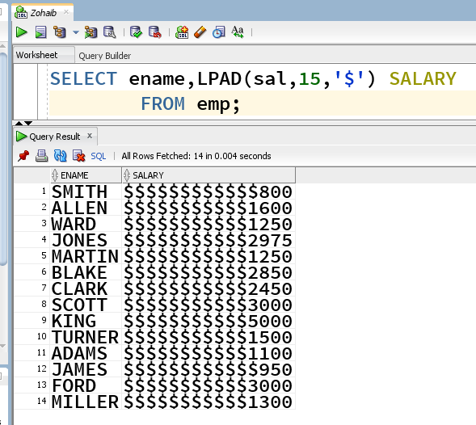

* iv. Write a query to display the current date. Label the column Date.

**ANS:**

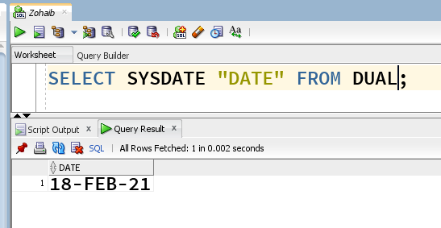

* v. Display the employee number, hire date, number of months employed, first Friday after hire date, and last day of the month.

**ANS:**

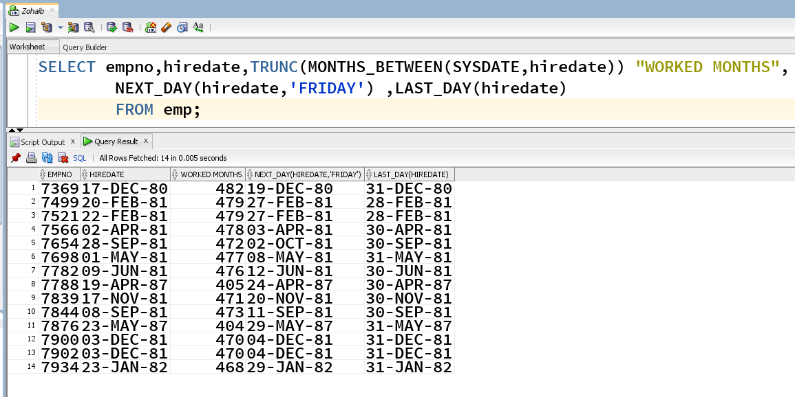

* vi. Create a query that displays the employees names and commission amounts. If an employee does not earn commission, show “No Commission.” Label the column COMM. (Hint: Use NVL Function)

**ANS:**

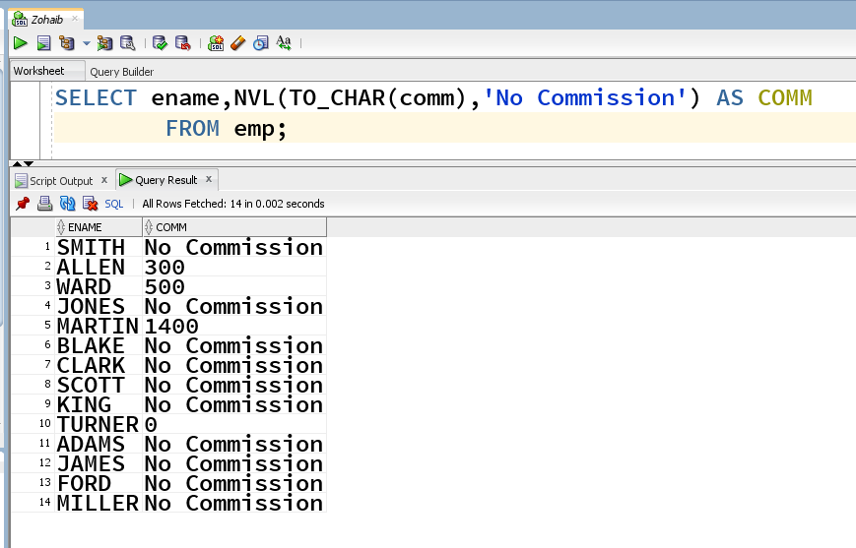

* **Q2. Run the following queries and display their outputs:**
* i. Display ename, hiredate and print the date in DD Month YYYY Format. Label the coulmn as “DATE FORMAT”. (Hint: Use To_CHAR Function)

**ANS:**

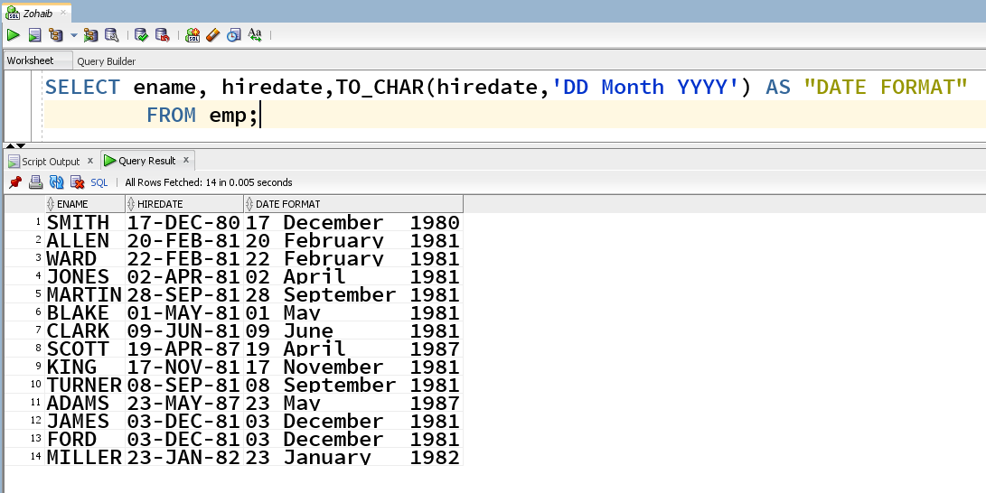

* ii. Write a query that generates the following output:
* **(OPTIONAL QUERY)**
* 1. Display the emp name, and email address. The email address will be composed from the four first letters of emp name concatenated with the string “@gmail.com”
* (For example : LEVI MARIO [levi@gmail.com](mailto:levi@gmail.com))

**ANS:**

